Case Study Report



**Tech Saksham**

Data Analytics with Power BI

**“Real-Time Analysis of Bank Customers”**

**“College Name”**

|  |  |
| --- | --- |
| **NM ID** | **NAME** |
| **261E4C668675AEDAB6C48F9E6781983E** | **R. GUNASEKARAN** |

Trainer Name: R. UMAMAHESWARI

Master Trainer: R. UMAMAHESWARI

**ABSTRACT**

This study explores the application of Power BI for real-time analysis of bank customers, aiming to enhance decision-making processes and improve customer satisfaction in the banking sector. Utilizing Power BI's interactive dashboards and robust data visualization capabilities, the research delves into various aspects of customer behavior, transaction patterns, and demographic insights. By integrating real-time data streams from multiple sources such as transaction records, customer profiles, and market trends, Power BI enables dynamic monitoring and analysis of customer interactions with the bank's services. The findings reveal actionable insights for personalized marketing strategies, targeted product offerings, and efficient resource allocation. Through the implementation of Power BI, banks can adapt swiftly to changing market dynamics, optimize operational efficiency, and cultivate enduring relationships with their clientele.

**INDEX**

|  |  |  |
| --- | --- | --- |
| **Sr. No.** | **Table of Contents** | **Page No.** |
| 1 | Chapter 1: Introduction | 1 |
| 2 | Chapter 2: Services and Tools Required | 4 |
| 3 | Chapter 3: Project Architecture | 5 |
| 4 | Chapter 4: Modeling and Result | 8 |
| 5 | Conclusion | 11 |
| 6 | Future Scope | 12 |
| 7 | Links | 13 |

**CHAPTER 1**

**INTRODUCTION**

* 1. **Problem Statement**

In the dynamic landscape of the banking industry, there exists a critical need for timely and insightful analysis of customer data to drive strategic decision-making and enhance customer experiences. Traditional methods of data analysis often fall short in providing real-time insights into customer behavior, leading to missed opportunities for personalized engagement and efficient resource allocation. Consequently, banks face challenges in effectively identifying emerging trends, mitigating risks, and maximizing profitability.

To address these challenges, this study focuses on leveraging the capabilities of Power BI for real-time analysis of bank customers. The primary goal is to develop a robust framework that enables banks to harness the power of real-time data streams and advanced analytics to gain actionable insights into customer behavior, preferences, and needs. By implementing Power BI, banks aim to overcome the limitations of traditional analysis methods and unlock the potential for proactive decision-making, targeted marketing initiatives, and improved operational efficiency.

**Proposed Solution**

The proposed solution for real-time analysis of bank customers using Power BI encompasses a multi-faceted approach that leverages the platform's capabilities to extract actionable insights from diverse data sources. The solution integrates Power BI's interactive dashboards, data visualization tools, and advanced analytics features to enable banks to effectively monitor, analyze, and respond to customer behavior in real-time.

* 1. **Feature**

1. **Data Integration and Streamlining**

* Implement connectors within Power BI to seamlessly integrate data from various sources such as transaction records, CRM systems, social media platforms, and market data feeds.
* Develop automated workflows to ingest and process real-time data streams, ensuring data consistency and accuracy.

2. **Real-Time Dashboards and Visualization:**

* Design intuitive dashboards using Power BI's drag-and-drop interface to visualize key performance indicators (KPIs), customer segmentation, and trend analysis in real-time.
* Incorporate interactive visualizations such as heatmaps, geographical maps, and drill-down charts to explore customer behavior at granular levels.

3. **Advanced Analytics and Machine Learning:**

* Utilize Power BI's built-in analytics capabilities and integration with Azure Machine Learning to perform predictive modeling, customer churn analysis, and product recommendation algorithms.
* Apply machine learning algorithms to detect anomalies in customer transactions, identify potential fraud, and enhance risk management practices.

4. **Personalized Insights and Recommendations:**

* Develop custom reports and dashboards tailored to individual customer profiles, allowing bank staff to provide personalized recommendations and targeted offers in real-time.
* Utilize Power BI's natural language processing (NLP) capabilities to enable ad-hoc querying and generate insights through conversational interfaces.

5. **Continuous Monitoring and Optimization:**

* Implement real-time alerts and notifications within Power BI to trigger proactive responses to critical events such as unusual transaction patterns, account activity, or market fluctuations.
* Continuously monitor the performance of real-time analytics models and iterate on the solution based on feedback and evolving business requirements.

**CHAPTER 2**

**SERVICES AND TOOLS REQUIRED**

**2.1 Tools and Software used**

**Tools**:

* **PowerBI**: The main tool for this project is PowerBI, which will be used to create interactive dashboards for real-time data visualization.
* **Power Query**: This is a data connection technology that enables you to discover, connect, combine, and refine data across a wide variety of sources.

**Software Requirements**:

* **PowerBI Desktop**: This is a Windows application that you can use to create reports and publish them to PowerBI.
* **PowerBI Service**: This is an online SaaS (Software as a Service) service that you use to publish reports, create new dashboards, and share insights.
* **PowerBI Mobile**: This is a mobile application that you can use to access your reports and dashboards on the go.

**CHAPTER 3**

**PROJECT ARCHITECTURE**

**3.1 Architecture**

**USER FRONTEND BACKEND**

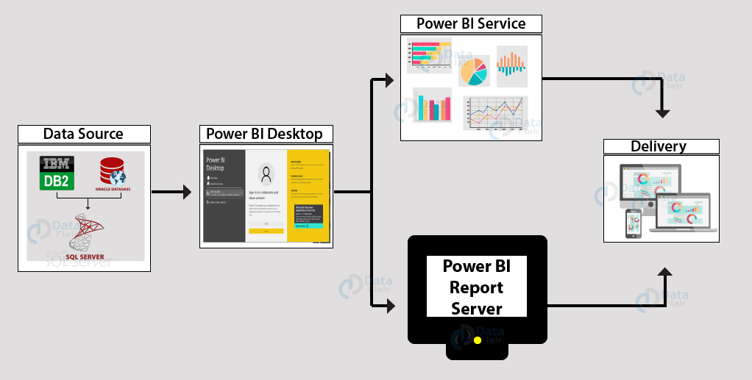

**Here’s a high-level architecture for the project:**

1. **Data Sources:**

* Transaction Records: Real-time transaction data from core banking systems.
* Customer Profiles: Demographic information, account details, and historical transaction data.
* External Data Feeds: Market data, economic indicators, social media sentiment analysis, etc.

2. **Data Ingestion:**

* Power BI utilizes connectors to ingest data from various sources, including databases, APIs, and streaming platforms.
* Real-time data streams are processed using Power BI's streaming datasets or Azure Stream Analytics for continuous ingestion and analysis.

3. **Data Processing and Transformation:**

* Data undergoes preprocessing and transformation to ensure consistency, accuracy, and compatibility with Power BI's data model.
* Transformations may include data cleansing, aggregation, enrichment, and normalization to prepare the data for analysis.

4. **Data Modeling:**

* Develop a robust data model within Power BI using tools such as Power Query and Power Pivot.
* Define relationships between different data entities to enable comprehensive analysis and visualization.

5. **Real-Time Analysis and Visualization:**

* Utilize Power BI's interactive dashboards, reports, and visualizations to analyze real-time data streams.
* Leverage features such as slicers, filters, and drill-downs to explore data at various levels of granularity.
* Incorporate dynamic visuals like KPIs, charts, graphs, and maps to convey insights effectively.

6. **Advanced Analytics and Machine Learning:**

* Integrate Azure Machine Learning services with Power BI for advanced analytics and predictive modeling.
* Deploy machine learning algorithms to detect patterns, anomalies, and trends in real-time customer data.
* Generate predictive forecasts, customer segmentation, and personalized recommendations based on analytical insights.

7. **Deployment and Scalability:**

* Deploy Power BI reports and dashboards to the cloud or on-premises environments based on organizational preferences.
* Ensure scalability and performance optimization through proper resource allocation and utilization of cloud services like Azure.

8. **Continuous Monitoring and Optimization:**

* Establish monitoring dashboards within Power BI to track key metrics, system performance, and data quality in real-time.
* Implement automated alerts and notifications to notify stakeholders of critical events or anomalies.
* Continuously optimize the architecture based on feedback, evolving business requirements, and technological advancements.

By adopting this high-level architecture, banks can leverage the capabilities of Power BI to perform real-time analysis of customer data, enabling them to make informed decisions, enhance customer experiences, and drive business growth in today's competitive banking landscape.

**CHAPTER 4**

**MODELING AND RESULT**

**Replacing Values**

Set some fields to English for easy understanding, we replace values to English with the Power Query Editor.

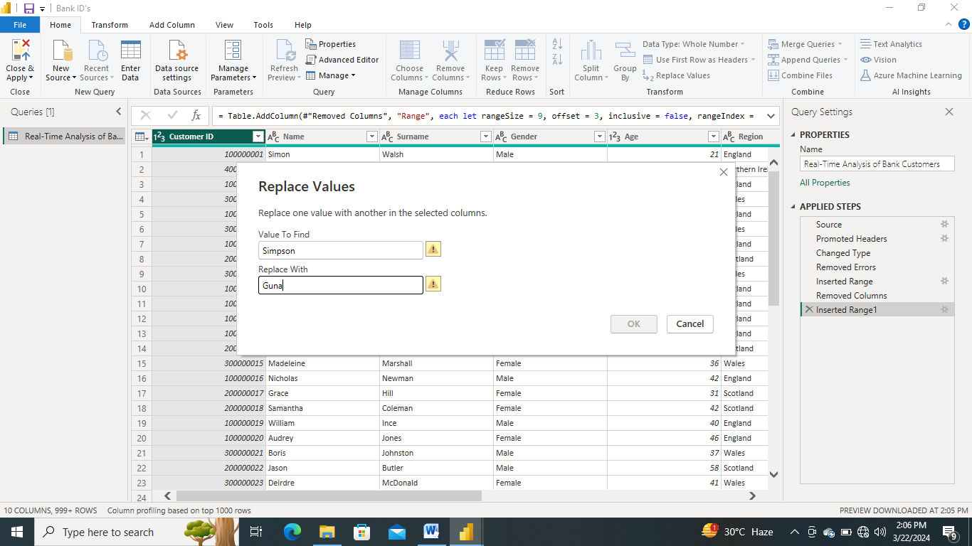

Changing the order of Region name at Power Query

Duplicate the “district /region” then split column using space as delimiter.

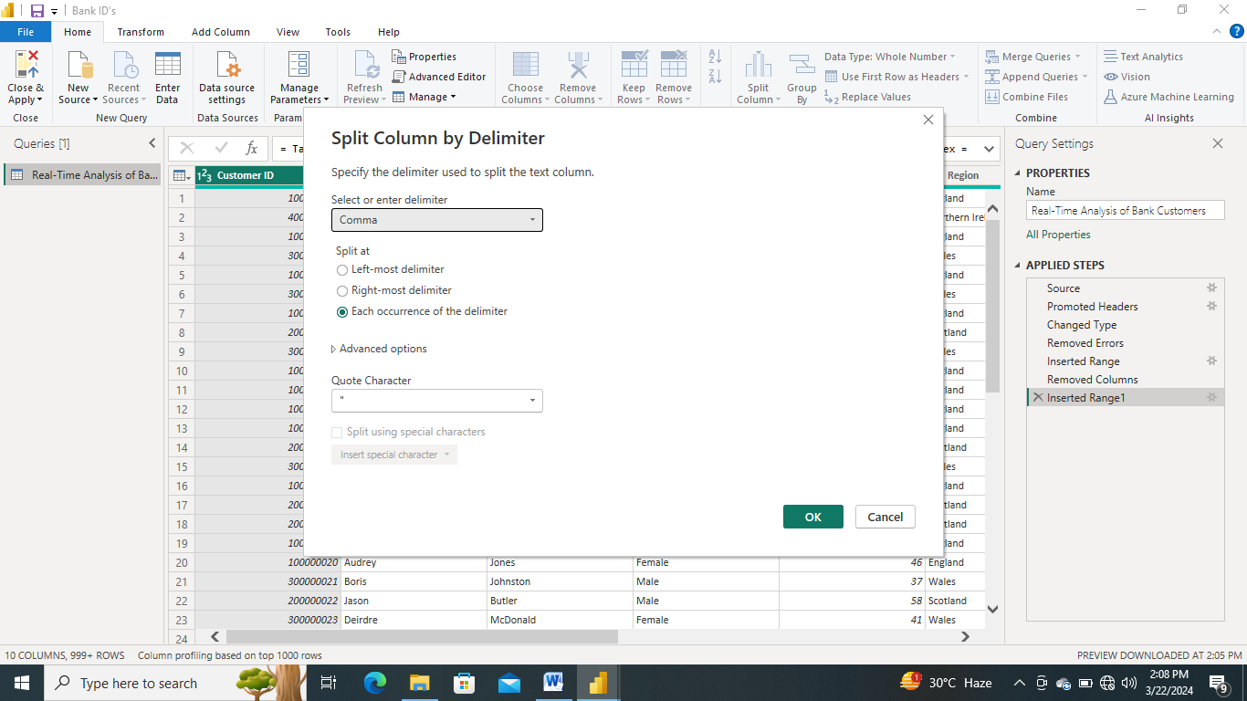

Then merge column by Region and direction. Refer to applied steps for details.

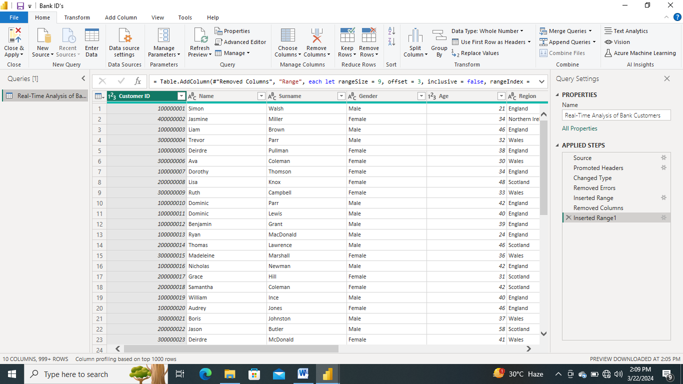

**Grouping of age by ranges**

As the customers’ age ranges from 12 to 88, we shall group them into different generation age range for easier profiling, we will group the ages into 5 groups.

The Gen Y are youths,

Gen X are young working adults, some starting their families

Baby Boomer are working adults with families.

The silent Generations some are working and retired, living on pensions.

The greatest Generation, retired elderly living on pensions.

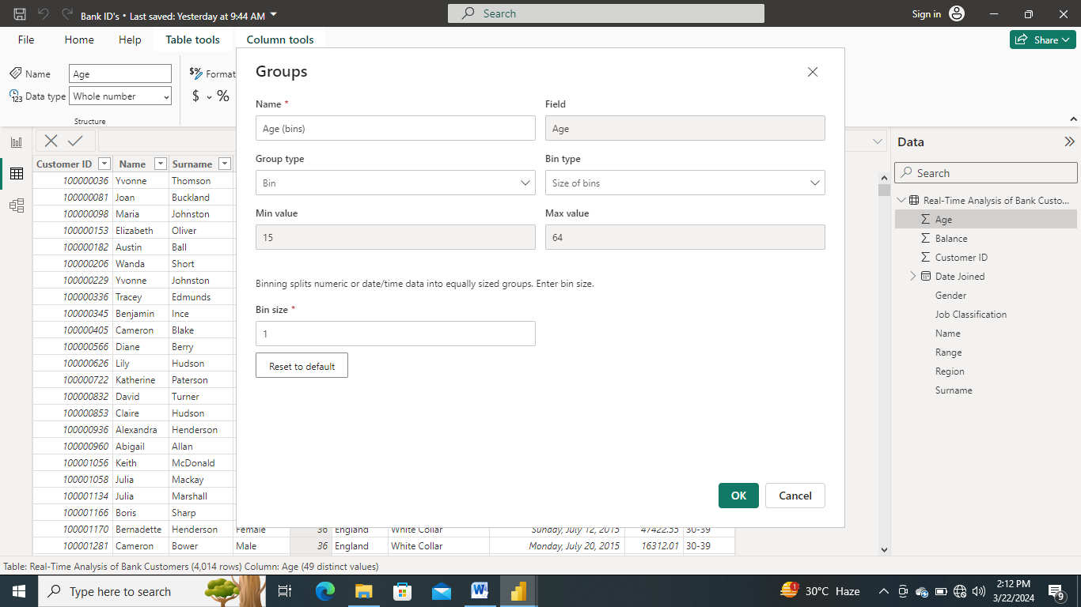

**Dashboard**

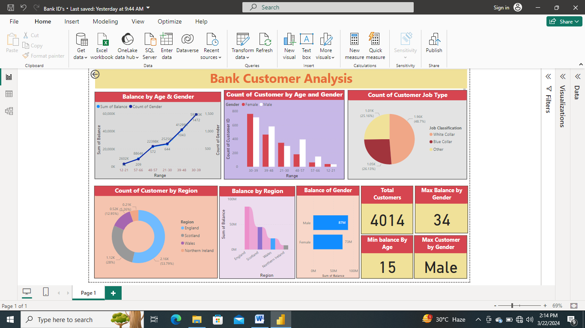

**CONCLUSION**

In conclusion, the adoption of Power BI for real-time analysis of bank customers represents a transformative opportunity for banks to stay ahead of the competition, drive innovation, and deliver exceptional value to their customers. By embracing data-driven decision-making and leveraging the full potential of Power BI, banks can unlock new insights, optimize processes, and drive sustainable growth in today's digital economy.

The application of Power BI for real-time analysis of bank customers offers significant opportunities for banks to gain actionable insights, improve operational efficiency, and enhance customer experiences. Through the utilization of Power BI's robust features and capabilities, banks can effectively harness the power of real-time data streams to drive strategic decision-making and achieve sustainable growth in today's dynamic banking landscape.

Throughout this study, we have explored the various aspects of real-time analysis of bank customers in Power BI, including data modeling, analysis techniques, and visualization methods. By leveraging Power BI's intuitive interface and advanced analytics tools, banks can transform raw data into meaningful insights, enabling them to better understand customer behavior, identify emerging trends, and anticipate market dynamics.

**FUTURE SCOPE**

The future scope of real-time analysis of bank customers in Power BI presents a multitude of exciting opportunities for innovation, optimization, and advancement in the banking sector. As technology continues to evolve and customer expectations evolve, banks can leverage Power BI to stay ahead of the curve and deliver exceptional value to their clientele. Here are some potential areas of future exploration:

1. **Enhanced Personalization:** With advancements in machine learning and artificial intelligence, banks can further personalize their offerings based on individual customer preferences, behaviors, and life events. Power BI can be utilized to analyze vast amounts of customer data in real-time, enabling banks to deliver hyper-personalized experiences tailored to each customer's unique needs and preferences.

2. **Predictive Analytics and Forecasting:** The integration of predictive analytics capabilities within Power BI opens up new avenues for banks to forecast customer behavior, market trends, and business performance with greater accuracy. By leveraging historical data and machine learning algorithms, banks can anticipate future opportunities and risks, enabling proactive decision-making and strategic planning.

3. **Real-Time Fraud Detection and Prevention:** As cyber threats continue to evolve, banks must remain vigilant in detecting and preventing fraudulent activities in real-time. Power BI can be augmented with advanced fraud detection algorithms and anomaly detection techniques to identify suspicious patterns and behaviors, enabling banks to take immediate action to mitigate risks and safeguard their assets.

In conclusion, the future of real-time analysis of bank customers in Power BI is brimming with possibilities for innovation and transformation in the banking sector. By embracing emerging technologies, leveraging data-driven insights, and fostering a culture of continuous learning and adaptation, banks can position themselves for long-term success and deliver exceptional value to their customers in the digital age.

**LINK**

[GitHub - onepiecegsr/Real-Time_Bank_Customer_Analysis](https://github.com/onepiecegsr/Real-Time_Bank_Customer_Analysis)